Faraday’s Law - Determination of the Value of the Faraday

NAME:________________________________________________ PERIOD:_______

Prelab

Part 2 of the experiment was performed using a copper anode and a stainless steel cathode.

1. Write the balanced equation for the reaction which occurs during the electrolysis.

2 In the electrolysis experiment, the following data were collected:

 | Trial 1
Current | 0.60 amps
Time | 270 sec
Mass of copper anode lost | 0.0512 g
Barometric pressure | 740.0 mm Hg
Temperature of the air and the solution | 20.0 ºC
Volume of the hydrogen gas | 30.5 mL
Height difference of the solution levels | 200 mm
Density of the solution | 1.05 g/mL
Mercury equivalent of the height difference | mm Hg
Adjusted total pressure  (barometric – mercury equivalent) | mm Hg
Vapor pressure of water | 17.5 mm Hg
Partial pressure of the hydrogen | mm Hg
Mass of hydrogen produced | g
Experimental value of the faraday based on the hydrogen | coul.
Experimental value of the faraday based on the copper | coul.

Show the calculations needed to complete the table above Use the back of this sheet.

3. If some of the evolved hydrogen escaped, would the calculated value of the faraday (from the volume of H₂) be high, low, or the same? Explain.

4. If some pieces of copper anode fell from the surface of the anode during the experiment, would the value of the faraday (from the mass of copper lost) be high, low, or the same? Explain.

Faraday’s Law - Determination of the Value of the Faraday

Early in the nineteenth century, Michael Faraday observed that the masses of the substances produced in an electrochemical reaction depend on the amount of current transferred at the electrode. The electrical charge on one mole of electrons is called the faraday in his honor. The electrical charge carried by one mole of electrons is one faraday.

In a given electrolysis reaction, the mass of the product formed or reactant consumed is proportional to the quantity of charge (Q in coulombs) passed through the cell. The rate of flow of electrical current is measured in amps. 1 amp = 1 coulomb/sec; 1 amp = 6.25x10¹⁸ electrons/sec.

Charge = Current x Time

Q (coulombs) = I (amps) x t (seconds)

Q = I t

One mole of electrons has a charge of 96,500 coulombs which equals one Faraday (F).

The same amount of charge passes through both half-cells but the number of moles of substance produced at a specific electrode depends on the number of electrons involved in the half-cell reaction. This number is represented by i. This number could be different for the two half-cells.

The mass of substance, g, produced at a specific electrode depends on the molar mass of the substance, MM.
Faraday’s Law is

The objective of this experiment is to demonstrate electrolysis reactions and the relationship between time, current, the moles, and the mass of the compounds produced. The data from the experiment will be used to calculate the value of the faraday.
In Part 1, copper metal will be plated on a copper mesh screen. The apparatus is shown below.

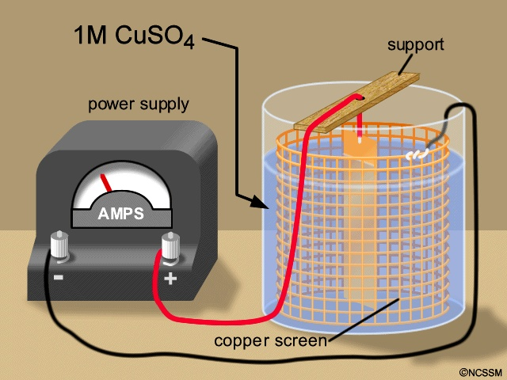

Copper ions are reduced at the cathode (black lead) and copper metal is oxidized at the anode (red lead). The half-cell reactions are:

Cathode reaction: Cu⁺²_{(aq)} + 2 e⁻ → Cu_{(s)}
Anode reaction: Cu_{(s)} → Cu⁺²_{(aq)} + 2 e⁻

The cathode gains mass since copper metal plates on that electrode. The anode loses mass since copper metal leaves that electrode in the form of copper ions. The concentration of copper ions in solution remains constant since copper ions are produced at the anode and consumed at the cathode.
The copper cathode will be massed at the beginning of the experiment. A measured current is passed through the cell for a measured amount of the time. The copper cathode will be massed at the end of the experiment. The increase in the mass of the cathode gives the mass of copper produced. With known values for the current, time, and mass of copper produced, the value of the faraday can be calculated.
In Part 2 of the experiment, a solution of sulfuric acid will be electrolyzed to produced hydrogen and oxygen gas. The apparatus is shown below.

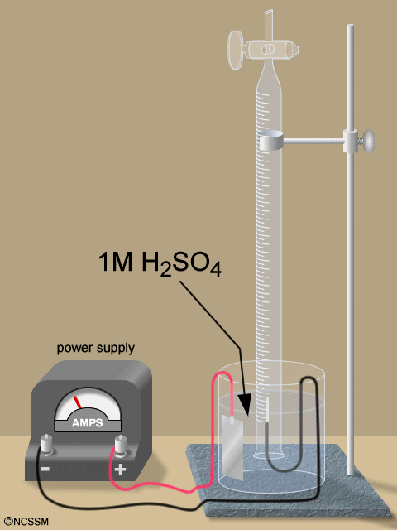

Hydrogen ions are reduced at the cathode (black lead) and water is oxidized at the anode (red lead). The half-cell reactions are:

Cathode reaction: 2 H⁺¹_{(aq)} + 2 e⁻ → H_{2 (g)}
Anode reaction: 2 H₂O _{(l)} → O_{2 (g)} + 4 H⁺¹_{(aq)} + 4 e⁻
Overall reaction: 2 H₂O _{(l)} → 2 H_{2 (g)} + O_{2 (g)}

A measured current is passed through the cell for a measured amount of the time. The hydrogen gas will be collected by displacement of the solution. The temperatures of the gas and the solution, the volume of the gas, and the barometric pressure are recorded. The vapor pressure of the solution is assumed to be the same as the vapor pressure of pure water. The vapor pressure of the water is subtracted from the barometric pressure to give the partial pressure of the hydrogen. The ideal gas equation is used to calculate the mass of the hydrogen. With known values for the current, time, and mass of hydrogen produced, the value of the faraday can be calculated.

Procedure:
Part 1: Electroplating of Copper

1. Obtain two copper electrodes. A hollow cylindrical-shaped wire screen is used for the cathode. A ½-in x 4-in. copper strip is used as the anode.

2. Clean the electrodes carefully by dipping them into 6 M HCl for minute using plastic forceps. Dip the electrodes in a beaker of rinse water. Rinse the electrodes with water and then with acetone into a waste beaker. Avoid touching the copper mesh electrode. Handle it using the attached wires. Let the electrodes dry in the air for a few minutes.

3. Mass the cathode to the nearest 0.01 g. Mass the cathode to the nearest 0.0001 g on an analytical balance if possible.

4. Place about 300 mL of 1-M CuSO₄ solution in a 400 mL beaker. Place the screen in the beaker and suspend the anode from a stirring rod. Do not allow the electrodes to touch each other in the solution.

5. Obtain a DC power supply which has a controls adjusting the voltage and the current and meters for reading their values. Connect the negative terminal (black lead) of the power supply to the copper mesh screen and the positive terminal (red lead) to the copper anode.

6. Have a stopwatch ready to measure the time the current is allowed to flow.

7. Start measuring the time at the instant you turn on the power supply. Adjust the current to about 1.00 amp and constantly adjust the voltage so that the current is maintained at 1.00 amp. Allow the cell to operate about twenty to thirty minutes. Record the current in the Data Table.

8. Turn off the power supply. Record the time the current was allowed to flow in the Data Table. Remove the electrodes from the solution. Avoid dislodging any of the copper deposited on the cathode. Carefully rinse the cathode with distilled water, then with acetone and allow it to dry in the air.

9. Mass the dry cathode to the nearest 0.01g or better and record the data in the table.

10. Repeat the procedure for trial 2 if directed to do so be your teacher.

Part 2 Electrolysis of an Aqueous Solution of H₂SO₄

1. Place about 300 mL of 1-M H₂SO₄ solution in a 400 mL beaker. The 1 M H₂SO₄ is very corrosive, therefore clean up any you may spill and avoid getting it on your skin or clothes.

2. Assemble the apparatus as illustrated in the figure above. The anode and cathode will be coated stainless steel wire. The electrode wire should be bent over the lip of the beaker so that it is firmly positioned. Clamp the gas buret to the ringstand. The buret should extend down over the bare wire of the cathode but not over an appreciable amount of the insulation. If the insulation goes very high into the buret, the current flow is appreciably reduced. Firm connections are important so that the electrodes do not move during the electrolysis; this would produce a change in the current.

3. Inspect the stopcock of the buret; the joint should be clear and the hole in the plug should be open.

4. Open the stopcock. Squeeze the rubber pipet bulb provided and attach it to the buret tip. Use the bulb to fill the buret with the solution. When it is full, close the stopcock and press it in firmly.

5. Obtain a DC power supply which has a controls adjusting the voltage and the current and meters for reading their values. Connect the negative terminal (black lead) of the power supply to the electrode in the buret and the positive terminal (red lead) to the other electrode.

6. Run a trial electrolysis to see if the apparatus is working properly. Turn on the power. See if all of the hydrogen evolved is going into the buret. If the cathode is improperly positioned or it there is a break in the insulation on the cathode, hydrogen can escape. Adjust the current to about 0.50 ampere using the voltage control on the power supply. If this value is not achieved, try raising the buret a bit or moving it and the cathode closer to the anode. The resistance of the solution can be decreased in this way.

7. Turn off the power. Refill the buret as in step 4.

8. Have a stopwatch ready to measure the time the current is allowed to flow.

9. Start measuring the time at the instant you turn on the power supply. Adjust the current to about 0.50 amp and constantly adjust the voltage so that the current is maintained at 0.50 amp. Allow the cell to operate until about 45 mL of gas are collected. Record the current in the Data Table.

10. Turn off the power supply. Record the time the current was allowed to flow in the Data Table.

11. Allow the small gas bubbles to finish rising in the buret and the system to come to room temperature.

12. Measure the air temperature which will be assumed to be the temperature of the hydrogen gas. Record the value in the Data Table.

13. Measure the solution temperature which will be used to determine the vapor pressure of the water. We will assume that the vapor pressure of the solution is the same as pure water. Record the value in the Data Table.

14. If possible, adjust the height of the buret so the liquid level is the same inside and outside the buret are the same. At that point, the total gas pressure inside the tube equals the atmospheric pressure outside the tube. The total pressure inside the tube is the partial pressure of the hydrogen gas plus the vapor pressure of the water.

15. If you are unable to adjust the height of the buret sufficiently to equalize the two levels, you instructor may instruct you to do one of the following.
a. Equalize the levels as close as possible and read the volume. If the height difference is small, it will have a negligible effect on your results.
b. Measure the height difference between the two liquid levels in mm. Assume that the density of the solution is essentially the same as pure water, 1.00 g/mL. The density of mercury is 13.6 g/mL. Divide the height difference between the two levels by 13.6 to give the equivalent pressure in mm Hg. Since the liquid level is higher inside the tube than outside the tube, the atmospheric pressure is greater than the pressure inside the tube. Subtract the equivalent pressure in mm Hg due to the height difference from the atmospheric pressure to give the total pressure inside the buret.
c. Measure the height difference between the two liquid levels in mm. Measure or you will be given density of the solution. Multiply the height by (the density of the solution/density of mercury). This gives the height difference equivalent pressure in mm Hg. Continue the calculation in step b above.

16. Read the atmospheric pressure from a barometer. Record the value in the Data Table.

17. Find the vapor pressure of the water at the solution’s temperature in a table of vapor pressures for water. Record the value in the Data Table. Subtract the vapor pressure of the water from the atmospheric pressure to get the partial pressure of the hydrogen gas. Record the value in the Data Table.

18. If you are using a gas buret or a gas measuring tube, read the volume of the hydrogen directly from the tube to the nearest 0.1 mL. Record the value in the Data Table.
19. If you are using a titration buret, it is not graduated with the zero at the stopcock the way a gas buret is graduated. Level the liquid levels if possible. Mark the height of the liquid level with a marking pen or a piece of tape. Lift the buret out of the solution and let the liquid drain into the beaker. Carefully handle the buret to avoid touching the solution on the outside of the beaker. Rinse the outside and the inside of the buret with water. Fill the buret to the mark with water. Pour the water into a 50 mL graduated cylinder and measure the volume to the nearest 0.1 mL. Record the value in the Data Table.

20. Use the partial pressure, the volume, and the temperature of the hydrogen to find the mass of the hydrogen produced.

21. Use Faraday’s law to find the value of the Faraday.

22. Your teacher may instruct you to do a second trial.

Faraday’s Law - Determination of the Value of the Faraday

NAME:__________________________________________ COURSE:___________

LAB PARTNER:___________________________________ PERIOD:___________

DATA TABLE

Part 1: Electroplating of Copper

 | Trial 1 | Trial 2
Initial mass of the cathode | g | g
Final mass of the cathode | g | g
Mass of copper plated | g | g
Current | amps | amps
Time | sec | sec
Moles of copper plated
Moles of electrons passed through the cell
Experimental value of the faraday | coul. | coul.
Theoretical value of the faraday | coul. | coul.
Percent error | % | %

Part 2 Electrolysis of an Aqueous Solution of H₂SO₄

 | Trial 1 | Trial 2
Current | amps | amps
Time | sec | sec
Barometric pressure | mm Hg
Temperature of the air | ºC
Temperature of the solution | ºC
Volume of the hydrogen gas | mL
Height difference of the solution levels | mm
Density of the solution | g/mL
Mercury equivalent of the height difference | mm Hg
Adjusted total pressure  (barometric – mercury equivalent) | mm Hg
Vapor pressure of water | mm Hg
Partial pressure of the hydrogen | mm Hg
Mass of hydrogen produced | g
Experimental value of the faraday | coul. | coul.
Theoretical value of the faraday | coul. | coul.
Percent error | % | %

Calculations:
Show your calculations for the mass of copper and hydrogen produced and the value of the faraday for Part 1 and 2.

Describe any sources of error you encountered and explain how they would affect your calculated value of the faraday (increase or decrease and why).

